Coding Challenge 3: Data visualization 2
Tyler Winter
2026-02-19
Table of Contents

Question 1

a. YAML Header
A YAML header is the section at the top of an R Markdown file between three dashes ---. It controls the document settings such as the title, author, date, and output format when the file is knitted.

b. Literate Programming
Literate programming is a way of writing code where explanation and code are combined in the same document. This allows the text, analysis, and results to be generated together.

Question 2
The manuscript associated with this data can be found here:
Noel et al. 2022. Endophytic fungi as promising biocontrol agent to protect wheat from Fusarium graminearum head blight. Plant Disease.
myco <- read.csv(
"MycotoxinData.csv",
na.strings = "na"
)
myco$Treatment <- as.factor(myco$Treatment)
myco$Cultivar <- as.factor(myco$Cultivar)
# set treatment order
myco$Treatment_ordered <- factor(
myco$Treatment,
levels = c("NTC", "Fg", "Fg + 37", "Fg + 40", "Fg + 70")
)
# DON base
p_don <- ggplot(myco, aes(x = Treatment_ordered, y = DON, color = Cultivar)) +
geom_boxplot(position = position_dodge(0.85), outlier.shape = NA) +
geom_point(position = position_jitterdodge(0.05, dodge.width = 0.85),
alpha = 0.6, size = 2) +
facet_wrap(~Cultivar) +
ylab("DON (ppm)") +
xlab("") +
scale_color_manual(values = cult_cols, name = "") +
theme_classic() +
theme(axis.text.x = element_text(angle = 45, hjust = 1))
# add pairwise
p_don_pwc <- p_don +
geom_pwc(aes(group = Cultivar),
method = "t_test",
label = "p.adj.format",
hide.ns = TRUE,
step.increase = 0.06)
p_don_pwc
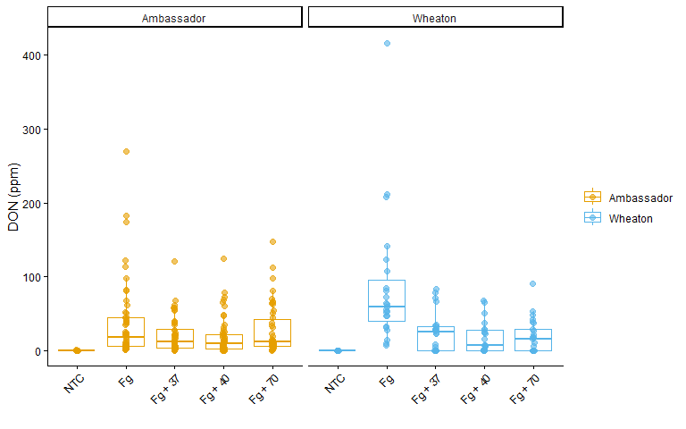
# 15ADON base
p_15adon <- ggplot(myco, aes(x = Treatment_ordered, y = X15ADON, color = Cultivar)) +
geom_boxplot(position = position_dodge(0.85), outlier.shape = NA) +
geom_point(position = position_jitterdodge(0.05, dodge.width = 0.85),
alpha = 0.6, size = 2) +
facet_wrap(~Cultivar) +
ylab("15ADON") +
xlab("") +
scale_color_manual(values = cult_cols, name = "") +
theme_classic() +
theme(axis.text.x = element_text(angle = 45, hjust = 1))
# add pairwise
p_15adon_pwc <- p_15adon +
geom_pwc(aes(group = Cultivar),
method = "t_test",
label = "p.adj.format",
hide.ns = TRUE,
step.increase = 0.06)
p_15adon_pwc
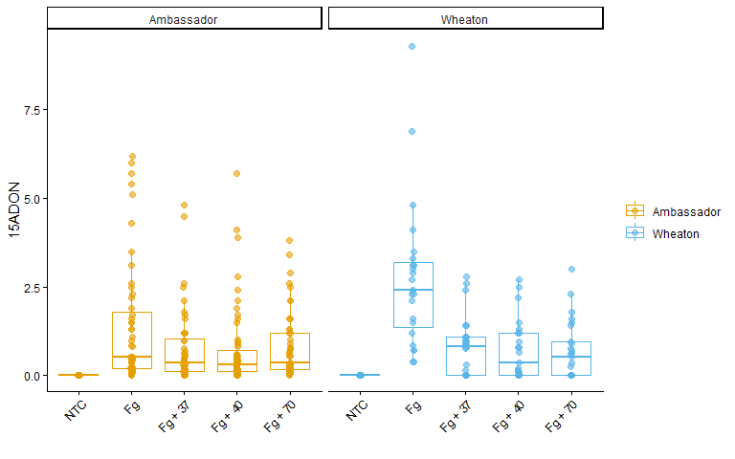
# Seed Mass base
p_seedmass <- ggplot(myco, aes(x = Treatment_ordered, y = MassperSeed_mg, color = Cultivar)) +
geom_boxplot(position = position_dodge(0.85), outlier.shape = NA) +
geom_point(position = position_jitterdodge(0.05, dodge.width = 0.85),
alpha = 0.6, size = 2) +
facet_wrap(~Cultivar) +
ylab("Seed Mass (mg)") +
xlab("") +
scale_color_manual(values = cult_cols, name = "") +
theme_classic() +
theme(axis.text.x = element_text(angle = 45, hjust = 1))
# add pairwise
p_seedmass_pwc <- p_seedmass +
geom_pwc(aes(group = Cultivar),
method = "t_test",
label = "p.adj.format",
hide.ns = TRUE,
step.increase = 0.06)
p_seedmass_pwc
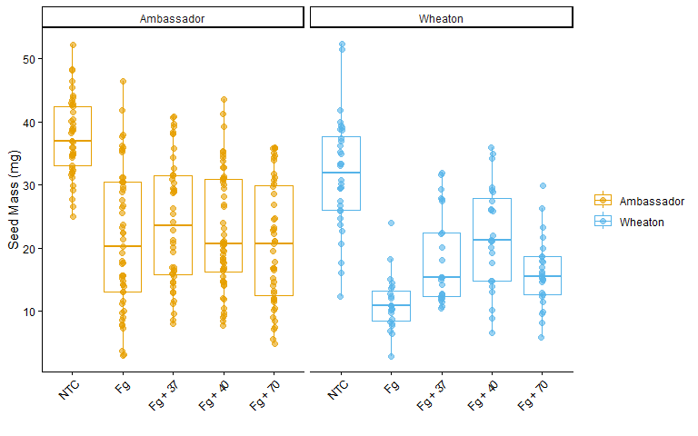
p_abc_pwc <- ggarrange(
p_don_pwc,
p_15adon_pwc,
p_seedmass_pwc,
ncol = 3,
nrow = 1,
labels = c("A", "B", "C"),
common.legend = TRUE,
legend = "bottom"
)
p_abc_pwc
